Market Segmentation Analysis

**Solo Contributor:**

Manda Shilpa

**Date 28/04/2023**

# Abstract:

Market segmentation analysis is the process of dividing a larger market into smaller groups or segments of consumers with similar needs, preferences, behaviors, or characteristics. The purpose of this analysis is to better understand and target specific groups of customers with tailored marketing strategies that meet their specific needs and preferences.

**Pictorial representation of the 10 steps of Market Segmentation Analysis**

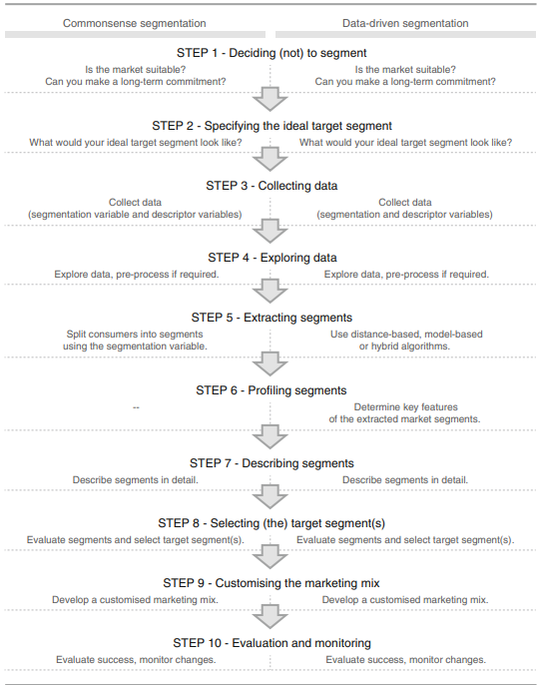

**Step1: Deciding (not) to Segment (Identify the Market)**

**Section 1**: Implications of Committing to Market Segmentation:

* Market segmentation requires a long-term organizational commitment and willingness to make substantial changes and investments.
* There are costs associated with market segmentation such as research, fielding surveys and focus groups, designing multiple packages and advertisements, and communication messages.
* Changes may include developing new products, modifying existing products, changing pricing and distribution channels, and adjusting the internal structure of the organization to target different market segments.

**Section 2**: Implementation Barriers

2.1: The first group of barriers is related to senior management:

* Lack of leadership
* Pro-active championing
* Commitment and involvement in market segmentation process by senior leadership
* Not making enough resources available for market segmentation analysis and implementation

2.2: The second group of barriers is related to organizational culture:

* Lack of market or consumer orientation
* Resistance to change and new ideas
* Lack of creative thinking
* Bad communication and lack of sharing of information and insights across organizational units
* Short-term thinking and unwillingness to make changes
* Lack of training

The lack of a formal marketing function or at least a qualified marketing expert in the organization can also represent major stumbling blocks.

The lack of a qualified data manager and analyst in the organization can be a major obstacle.

Most of these barriers can be identified from the outset of a market segmentation study and proactively removed.

If barriers cannot be removed, seriously consider abandoning the attempt of exploring market segmentation as a potential future strategy.

**Step 2: Specifying the Ideal Target Segment**

**Segment Evaluation Criteria:**

In the process of market segmentation analysis, it is important to consider user input beyond just a briefing at the start or the development of a marketing mix at the end. The segmentation team should select the criteria they want to use to determine how attractive potential target segments are, and assess the relative importance of each criterion to the organization. This results in a diverse set of attractiveness criteria, from which the team can select approximately six segment evaluation criteria with a weight attached to each to indicate their importance to the organization.

# Knock-Out Criteria

Knock-out criteria are used to eliminate market segments that do not qualify for further assessment using segment attractiveness criteria.

The six knock-out criteria are:

1. Homogeneity refers to the similarity among members of a segment.
2. Distinctiveness means that members of a segment should be distinctly different from members of other segments.
3. The segment must be large enough to make it worthwhile to customize the marketing mix.
4. The organization must have the capability to satisfy segment members' needs, which refers to the match between segment needs and the organization's strengths.
5. Identifiability means that segment members can be identified in the marketplace.
6. Reachability means that there must be a way to get in touch with segment members to make the customized marketing mix accessible to them.

Knock-out criteria must be understood by senior management, the segmentation team, and the advisory committee.

**Attractiveness criteria**

* Attractiveness criteria are used to evaluate how attractive potential target segments are.
* Each market segment is rated based on how well it meets each attractiveness criterion.
* Attractiveness criteria are not binary and segments are not assessed as complying or not complying.
* The market segmentation team should have a list of approximately six attractiveness criteria.
* Each attractiveness criterion should have a weight attached to indicate its relative importance to the organization.

# Step 3: Collecting Data

Market segmentation requires the use of segmentation variables and criteria to divide a sample population into different segments. Data can be collected from various sources, including surveys, internal sources, and experimental studies. However, biases may affect the quality of the results obtained from survey data.

**Segmentation Variables:**

* Refers to the variable used to divide a sample into market segments
* Typically a single characteristic of the consumers in the sample

**Segmentation Criteria:**

* Broad term that refers to the nature of the information used for market segmentation
* May relate to specific constructs, such as benefits sought

**Data Collection:**

* Requires identifying the necessary information for informed decisions about market segmentation
* Includes demographic, psychographic, geographic, and behavioral data.

**Survey Data:**

* Cheap and easy to collect, making it a common approach for market segmentation analysis
* Prone to biases that may affect the quality of the results obtained
* Key aspects to consider include the choice of variables, response options, response styles, and sample size.

**Internal Data:**

* Increasingly available and useful for market segmentation analysis
* Examples include scanner data for grocery stores, booking data from airline loyalty programs, and online purchased data.

**Experimental Data:**

* Results from field or laboratory experiments
* Aim to test how people respond to specific stimuli, such as advertisements

**Step 4: Exploring Data**

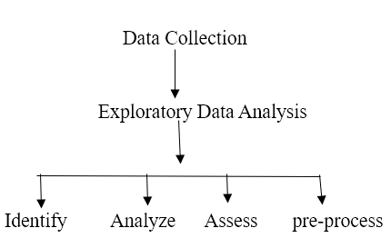

**7 Steps to follow:**

1. **Data exploration**
2. **Data cleaning**
3. **Data pre-processing**
4. **Check variables/sample size**
5. **Variable subset selection**
6. **Correlation check**
7. **Data handover**

* Exploring the data and determining any inconsistencies and systematic contaminations is the responsibility of the data analyst or the person responsible for conducting the market segmentation study. This task involves examining the data to check for any outliers, missing values, or errors that may have occurred during data collection.
* If necessary, cleaning the data is also the responsibility of the data analyst. This involves removing any errors, inconsistencies, or missing values from the dataset. Cleaning the data ensures that the dataset is consistent and accurate before further analysis.
* Pre-processing the data is also the responsibility of the data analyst. This task involves transforming the data to make it suitable for analysis. For example, converting categorical data into numerical data, normalizing the data, or scaling the data.

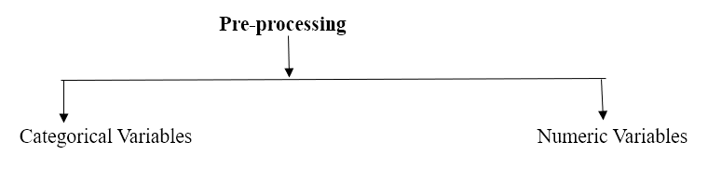

* Checking if the number of segmentation variables is too high given the available sample size is the responsibility of the data analyst or the market segmentation team. This task involves ensuring that there are enough respondents for each segmentation variable. A minimum of 100 consumers for each segmentation variable is recommended.
* If there are too many segmentation variables, selecting a subset of variables is also the responsibility of the data analyst or the market segmentation team. This task involves using available approaches, such as factor analysis or principal component analysis, to reduce the number of variables to a manageable number.

**PCA**

PCA is a powerful tool for dimensionality reduction and data exploration. By transforming the data into a new set of variables, it is possible to identify patterns and relationships that may not be apparent in the original data. This can be especially useful when working with high-dimensional data, where visualizing and analyzing the data can be difficult.

In addition to exploring data and identifying highly correlated variables, PCA can also be used for feature extraction and data compression. By selecting only the most important principal components, it is possible to reduce the dimensionality of the data while still retaining most of the information. This can be useful for applications where storage or processing resources are limited.

Overall, PCA is a powerful and versatile tool that can be used for a variety of data analysis tasks. However, it is important to keep in mind that the interpretation of the principal components can be difficult, and care must be taken when interpreting the results.

* Checking if the segmentation variables are correlated is the responsibility of the data analyst. This task involves examining the correlation matrix to identify any highly correlated variables. If there are highly correlated variables, choosing a subset of uncorrelated variables is recommended to avoid multicollinearity.
* Passing on the cleaned and pre-processed data to the next step of segment extraction is the responsibility of the data analyst or the market segmentation team. The cleaned and pre-processed data is ready for further analysis, such as segment extraction using suitable segmentation algorithms.

**Step 5: Extracting Segments**

**1. Grouping Consumers**

Market segmentation is a process of dividing a market into smaller groups of consumers who share similar needs or characteristics. Grouping consumers helps companies tailor their marketing strategies and products to specific segments, resulting in more effective marketing efforts and increased profitability.

However, grouping consumers is not a simple task as consumer data sets are typically unstructured and not well separated. Therefore, market segmentation analysis is exploratory by nature and strongly depends on the assumptions made on the structure of the segments implied by the method.

One of the most popular methods used for market segmentation is cluster analysis, where market segments correspond to clusters. Different algorithms for cluster analysis have different tendencies of imposing structure on the extracted segments. For example, k-means clustering aims at finding compact clusters covering a similar range in all dimensions, whereas single linkage hierarchical clustering constructs snake-shaped clusters.

There is no single best algorithm for all data sets, and the choice of algorithm will depend on the data set characteristics and expected or desired segment characteristics. Investigating and comparing alternative segmentation solutions is critical to arriving at a good final solution.

In addition to **distance-based and model-based methods** for market segmentation, some methods perform variable selection during the extraction of market segments. However, each method has its advantages and disadvantages, and no one method outperforms others in all situations.

**1.1 Distance-Based Methods**

There are several distance measures that can be used to **calculate similarity or dissimilarity** between groups of tourists based on their vacation activity patterns. Here are some commonly used ones:

**Euclidean distance**: This is the most commonly used distance measure, and is defined as the square root of the sum of the squared differences between each pair of activity percentages. It assumes that the variables are continuous and follow a normal distribution.

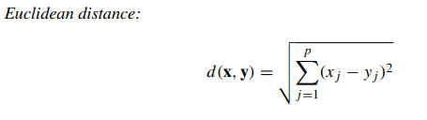

**Manhattan distance:** This is also known as the L1 distance and is calculated as the sum of the absolute differences between each pair of activity percentages. It is appropriate when the variables are not normally distributed and have outliers.

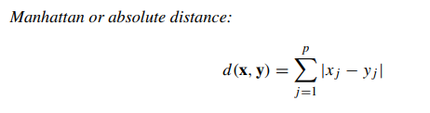

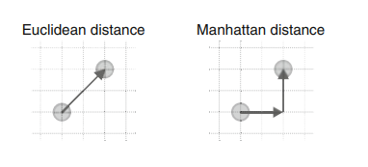

**Cosine distance:** This is a similarity measure that calculates the cosine of the angle between two vectors of activity percentages. It is useful when the magnitude of the vectors is not important and only their orientation matters.

**Jaccard distance**: This is a distance measure that calculates the dissimilarity between two sets of activity percentages. It is defined as the ratio of the number of elements that are different between the two sets to the total number of elements in the two sets.

Depending on the specific needs of the analysis and the characteristics of the data, one of these distance measures or a combination of them may be used to group tourists into segments based on their vacation activity patterns.

**1.2 Hierarchical Methods**

Hierarchical clustering methods group data into segments and are intuitive.

Divisive clustering starts with the complete data set and splits it into two segments, while agglomerative clustering starts with each consumer representing their own segment and merges the closest two segments step-by-step.

Both approaches result in a sequence of nested partitions ranging from partitions containing only one group to n groups.

The linkage method generalizes how distances between groups of observations are obtained.

The standard linkage methods available in the R function hclust() are single linkage, complete linkage, and average linkage.

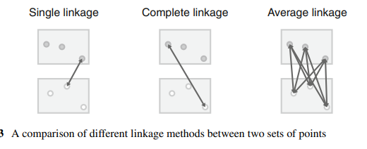

Different combinations of distance measure and linkage method can reveal different features of the data.

Single linkage is capable of revealing non-convex, non-linear structures, while average and complete linkage extract more compact clusters.

Ward clustering is a popular alternative method based on squared Euclidean distances.

The result of hierarchical clustering is typically presented as a dendrogram, which is a tree diagram showing the sequence of nested partitions.

**1.3 Partitioning Methods**

* Hierarchical clustering is best for small datasets with up to a few hundred observations.
* For larger datasets, clustering methods that create a single partition are more suitable.
* Instead of computing all pairwise distances between observations, distances between each observation and the center of segments can be computed.
* For a dataset with 1000 consumers, agglomerative hierarchical clustering would have to calculate 499,500 distances for the pairwise distance matrix between all consumers.
* Partitioning clustering algorithms that aim to extract a specific number of segments only have to calculate between 5 and 5000 distances at each step.
* It's better to optimize specifically for extracting a few segments rather than building the complete dendrogram and then heuristically cutting it into segments.

1. **k-Means and k-Centroid Clustering**

K-means clustering is a partitioning method in unsupervised machine learning used for dividing a dataset into groups (clusters) based on similarity/dissimilarity. The objective is to create clusters of data points in a way that points within the same cluster are as similar as possible to each other, while points in different clusters are as dissimilar as possible.

The method involves the following steps:

1. Specify the desired number of clusters (k).
2. Randomly select k observations (data points) from the dataset and use them as the initial set of cluster centroids.
3. Assign each observation to the nearest cluster centroid based on the chosen distance measure (usually squared Euclidean distance).
4. Recalculate the cluster centroids as the mean (in the case of squared Euclidean distance) of all observations assigned to that cluster.
5. Repeat steps 3 and 4 until convergence is achieved (i.e., no more updates are needed or a maximum number of iterations has been reached).

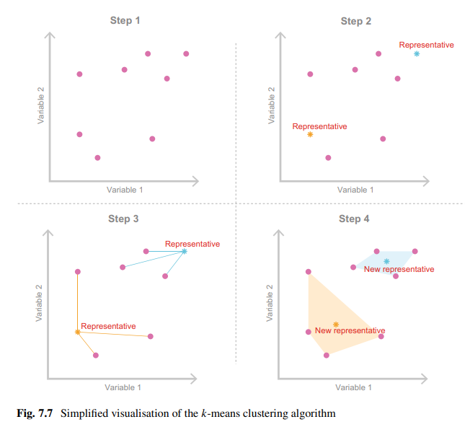

K-means clustering is an iterative algorithm that aims to minimize the sum of squared distances between each data point and its assigned cluster centroid. The algorithm is not guaranteed to find the global optimum, but it usually converges to a local minimum, which is a suboptimal solution. Additionally, there are variations of the k-means algorithm, such as k-medians and k-modes, that use different distance measures and methods for calculating the cluster centroids.

1. **“Improved” k-Means**

On improving the k-means clustering algorithm. Using "smart" starting values rather than randomly drawing k consumers from the data set can certainly help avoid the problem of the algorithm getting stuck in a local optimum. It's interesting to note that using starting points that are evenly spread across the entire data space can better represent the entire data set and potentially lead to better solutions.

1. **Hard Competitive Learning**

Hard competitive learning is also known as learning vector quantisation and differs from k-means in how segments are extracted.

Both methods minimize the sum of distances from each consumer to their closest representative (centroid), but the process is different.

K-means uses all consumers in the data set at each iteration to determine new centroids, while hard competitive learning randomly picks one consumer and moves its closest centroid a small step towards the randomly chosen consumer.

Different segmentation solutions can emerge from the two methods even if the same starting points are used.

Hard competitive learning may find the globally optimal solution while k-means gets stuck in a local optimum, or vice versa.

Neither method is superior to the other; they are just different.

Hard competitive learning has been used in market segmentation analysis for segment-specific market basket analysis.

Hard competitive learning can be computed in R using the cclust function from the flexclust package, with the method parameter set to "hardcl".

1. **Neural Gas and Topology Representing Networks**

Neural gas algorithm is a variation of hard competitive learning that adjusts the location of the second closest segment representative towards the randomly selected consumer.

Topology representing networks (TRN) extends the neural gas algorithm by building a virtual map where similar segment representatives are placed next to each other.

The segment neighborhood graph can be generated from the final segmentation solution of any clustering algorithm by counting how many consumers have certain representatives as closest and second closest.

There is currently no implementation of the original TRN algorithm in R, but using neural gas in combination with neighborhood graphs achieves similar results.

Different segmentation solutions can emerge from different clustering algorithms, including k-means, hard competitive learning, neural gas, and TRN.

Having a larger toolbox of algorithms available for exploration is of great value in data-driven market segmentation analysis.

1. **Self-Organising Maps**

Self-organizing maps (SOMs) are a variation of hard competitive learning used for market segmentation.

SOMs position segment representatives (centroids) on a regular grid.

The algorithm is similar to hard competitive learning, where a single random consumer is selected and the closest representative moves towards it.

Representatives that are direct grid neighbors of the closest representative also move towards the random consumer.

The adjustments to the locations of the centroids get smaller and smaller until a final solution is reached.

The advantage of SOMs is that the numbering of market segments aligns with the grid along which all segment representatives are positioned.

However, the sum of distances between segment members and segment representatives can be larger than for other clustering algorithms due to the restrictions imposed by the grid.

Comparisons of SOMs and topology representing networks with other clustering algorithms are provided in literature.

1. **Neural Networks**

Auto-encoding neural networks provide a different approach to cluster analysis compared to traditional clustering methods. The key idea behind auto-encoders is to use a neural network to learn a compressed representation of the input data, such that the compressed representation can be used as a representation of clusters or segments. The process of learning this compressed representation is often referred to as training the network.

The architecture of an auto-encoder typically consists of an input layer, a hidden layer, and an output layer. The input layer takes the raw data as input, the output layer produces a reconstructed version of the input data, and the hidden layer provides a compressed representation of the input data. During training, the network is optimized to minimize the difference between the input data and the reconstructed output data.

Once the network is trained, the hidden layer can be used as a representation of clusters or segments. Consumers that have similar hidden layer values are considered to be members of the same segment. Auto-encoder clustering typically results in fuzzy segmentations, where consumers may belong to multiple segments with membership values between 0 and 1.

Auto-encoding neural networks have the advantage that they can learn non-linear relationships between input variables, which traditional clustering methods may not be able to capture. Additionally, auto-encoders can learn to represent data in a lower-dimensional space, which can be useful for data visualization.

There are several implementations of auto-encoding neural networks available in popular programming languages such as R and Python. The R package autoencoder provides an implementation of auto-encoding neural networks, while the fclust package provides implementations of other fuzzy clustering algorithms.

**1.4 Hybrid Approaches**

1. **Two-Step Clustering**

Two-step clustering is a data clustering technique that involves two steps, as the name suggests. In the first step, a partitioning clustering method, such as k-means, is used to divide the data into a large number of small, homogeneous clusters. The primary objective of this step is to reduce the size of the data set by retaining only one representative member of each cluster. This step is also referred to as vector quantization. In the second step, a hierarchical clustering method is applied to the representative members obtained in the first step, and the original data is linked to the resulting segmentation solution.

The second step uses the cluster centers and segment sizes obtained from the first step as input to the hierarchical clustering method. The resulting dendrogram produced by hierarchical clustering is analyzed to identify the natural segments within the data. However, it cannot be determined which observation belongs to which segment without linking the original data with the hierarchical clustering solution. This is done using the twoStep() function, which takes as arguments the hierarchical clustering solution, the cluster memberships of the original data obtained with the partitioning clustering method, and the number of segments to extract.

Two-step clustering is often used in situations where the number of natural segments in the data is unknown or not well defined. The two-step approach allows for a more robust and accurate segmentation solution by combining the strengths of both partitioning and hierarchical clustering methods. The approach has been applied in various fields, including market research, social science, and healthcare.

1. **Bagged Clustering**

Bagged clustering is a type of clustering algorithm that combines partitioning clustering and hierarchical clustering techniques while also using bootstrapping. Bootstrapping is a process of randomly drawing samples from the original data set, with replacement. The main advantage of this method is that it makes the segmentation solution less dependent on the exact people contained in consumer data.

In the first step of bagged clustering, the data set is bootstrapped to create many random samples. For each sample, a partitioning algorithm is applied to cluster the data, and the resulting centroids are saved. These centroids are then used as the data set for hierarchical clustering. The dendrogram from hierarchical clustering provides clues about the best number of market segments to extract.

Bagged clustering is suitable for situations where niche markets are suspected, standard algorithms might get stuck in bad local solutions, or hierarchical clustering is preferred, but the data set is too large. It consists of five steps, including creating bootstrap samples, repeating the partitioning method, using cluster centers to create a new data set, calculating hierarchical clustering, and determining the final segmentation solution.

Bagged clustering has been applied to tourism data and has been successful in identifying market segments based on winter vacation activities, as illustrated by the winter vacation activities data from the Austrian National Guest Survey.

**1.2 Model-Based Methods**

Model-based methods are a flexible and powerful alternative to distance-based methods for market segmentation analysis. They rely on assumptions about the underlying structure of the market segments, but they allow for more complex and nuanced relationships between consumer characteristics and segment membership. By using a range of extraction methods, data analysts can better understand the nature of the market and make more informed marketing decisions.

A mixture of several multivariate **normal distributions** is a popular choice for finite mixture models when the segmentation variables are metric. This is because the multivariate normal distribution can easily model covariance between variables, which is often present in real-world data. As you mentioned, this covariance can arise from physical measurements on humans, such as height, arm length, leg length, or foot length, or from business data, such as prices in markets with many players. By using a mixture of normal distributions, we can segment the data based on the different mean and covariance structures of each segment, which can provide insights into the underlying patterns and relationships in the data

Finite mixtures of regression models can be used to identify these different segments and estimate the regression relationship between the number of rides and the entrance fee separately for each segment. The basic idea behind finite mixture models is to assume that the data is generated by a mixture of several subpopulations, each with its own probability distribution.

In the context of finite mixtures of regression models, we assume that the data is generated by a mixture of several subpopulations, each with its own regression function. The probability of belonging to each subpopulation is represented by a weight. The regression coefficients and the error term of each subpopulation are estimated separately.

By estimating these parameters, we can identify the different subpopulations or segments of consumers with different levels of willingness to pay based on the number of rides. We can also estimate the regression relationship between the number of rides and the entrance fee separately for each segment. This allows us to identify the optimal price for each segment, which can improve revenue and profitability.

**4 Algorithms with Integrated Variable Selection**

When working with binary segmentation variables, it can be challenging to identify and remove redundant or noisy variables during data pre-processing. In such cases, algorithms that simultaneously extract segments and select suitable segmentation variables are required. Biclustering and the variable selection procedure for clustering binary data (VSBD) are two such algorithms. Additionally, factor-cluster analysis is a two-step approach that compresses segmentation variables into factors before segment extraction. It is important to carefully select segmentation variables, as the performance of clustering algorithms is heavily influenced by the quality of segmentation variables used.

**5 Data Structure Analysis**

Cluster indices, gorge plots, global stability analysis, and segment level stability analysis are all approaches to data structure analysis, which provides insights into the properties of the data and guides subsequent methodological decisions.

1. Cluster indices are measures of the quality of a clustering solution, and there are various indices available, such as the silhouette coefficient, Dunn index, and Calinski-Harabasz index. These indices can help to identify the optimal number of clusters and compare different clustering solutions.

1. Gorge plots are graphical representations of clustering solutions, which show how the within-cluster sum of squares (WSS) changes as the number of clusters increases. Gorge plots can help to identify the optimal number of clusters by looking for the "elbow" in the plot, where the decrease in WSS slows down significantly.

1. Global stability analysis involves repeating the segmentation algorithm multiple times on slightly modified versions of the data, such as bootstrap samples or subsets of variables. The resulting segmentation solutions can be compared to assess the stability of the clusters across different data sets.

1. Segment level stability analysis involves comparing the clustering solutions obtained from different subsets of the data, such as different time periods or different geographical regions. This can help to assess the stability of the clusters over time or across different markets.

Overall, data structure analysis can help to identify the presence and nature of natural, distinct, and well-separated market segments in the data, as well as to choose the optimal number of segments to extract.

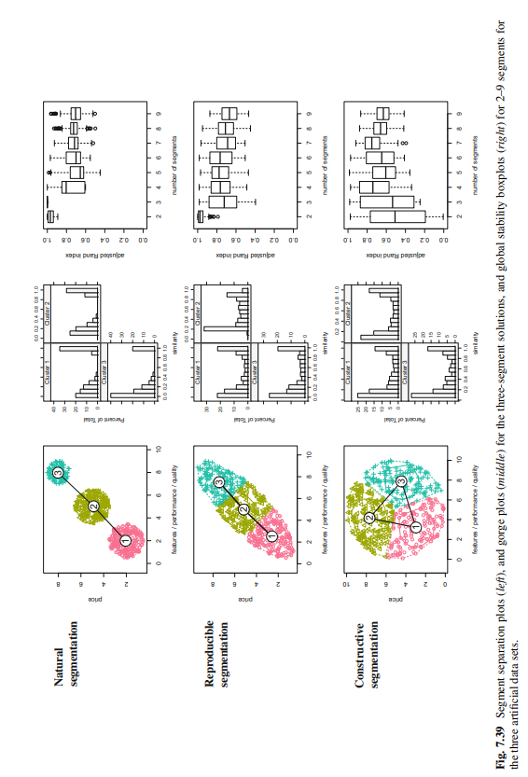

# Grouping Consumers:

# This method involves manually grouping consumers based on certain characteristics such as age, gender, income, or lifestyle. This method is often used in small businesses or for niche markets with clearly defined consumer segments. For example, a high-end fashion boutique may group consumers by their purchasing behavior, such as frequent buyers or occasional buyers.

# 

# Distance-Based Methods:

# This method involves measuring the distance between different consumers based on certain characteristics and then grouping them based on their proximity. One popular distance-based method is cluster analysis, which groups consumers based on similarities in their characteristics. For example, a hotel chain may use cluster analysis to group consumers based on their travel behavior, such as frequent business travelers or leisure travelers.

# 

# Model-Based Methods:

# This method involves using statistical models to identify the best segmentation solution based on the data. One popular model-based method is factor analysis, which identifies underlying factors that explain the variance in the data. For example, a car manufacturer may use factor analysis to identify the main factors that influence consumer preferences, such as fuel efficiency, safety, or style.

# 

# Algorithms with Integrated Variable Selection:

# This method involves using algorithms that automatically select the most important variables for segmentation. One popular algorithm is decision trees, which use a series of branching questions to segment consumers based on their characteristics. For example, a grocery store may use a decision tree to segment consumers based on their purchasing behavior, such as organic vs. non-organic buyers.

# 

# Data Structure Analysis:

# This method involves analyzing the structure of the data to identify the most natural segments. One popular data structure analysis method is Latent Class Analysis (LCA), which groups consumers based on their response patterns to a set of survey questions. For example, a financial services company may use LCA to group consumers based on their risk preferences, such as conservative or aggressive investors.

# 

# Overall, there are multiple methods for extracting segments in market segmentation analysis, and each method has its own strengths and weaknesses. The method chosen will depend on the research objectives, the available data, and the specific needs of the business.

# 

# 

# 

# Step 6: Profiling Segments

# Identifying Key Characteristics of Market Segments:

The profiling step is necessary for data-driven market segmentation, but not for commonsense segmentation where profiles are predefined. Profiling involves characterizing market segments and comparing them to other segments. It is important to consider alternative segmentation solutions, especially when there are no natural segments in the data. Reproducible or constructive approaches may be necessary.

# Traditional Approaches to Profiling Market Segments:

* Data-driven segmentation solutions can be presented to users in two ways: high level summaries or large tables with exact percentages for each segment and segmentation variable.
* To identify defining characteristics of market segments, percentage values for each variable need to be compared with values of other segments or the total value in the far right column.
* Information about statistical significance of differences between segments for each variable may be provided, but this approach is not statistically correct because segments are created to be maximally different and not suitable for standard statistical tests.
* Segment membership is directly derived from segmentation variables, and statistical tests cannot be used to assess the significance of differences.

# Segment Profiling Visualization

* Graphics are essential in exploratory statistical analysis to gain insights into the complex relationships between variables.
* Visualization offers a simple way to monitor developments over time, which is particularly important in the era of big data.
* Visualization techniques should be recommended to make market segmentation analysis results easier to interpret.
* Visualization can help identify patterns, relationships, and differences between segments more easily than tables or numerical summaries.
* The use of visual aids can improve communication and understanding of the results, especially for non-technical stakeholders.

# Identifying Defining Characteristics of Market Segments

* A segment profile plot is a useful tool for understanding the defining characteristics of each market segment.
* It shows how each segment differs from the overall sample for all segmentation variables.
* The plot can be used to visually compare the answer patterns of each segment and identify similarities or differences between them.
* The segment profile plot is a direct visual representation of the ordering of segmentation variables by similarity of answer patterns in a table.

# Assessing Segment Separation

* A segment separation plot is a visualization tool for showing the overlap of segments across relevant dimensions of the data space.
* The plot is particularly useful for identifying how well-separated segments are.
* Segment separation plots are straightforward when the number of segmentation variables is low, but can become complex with more variables.
* Even in complex situations, segment separation plots provide a quick overview of the data situation and segmentation solution for data analysts and users.

**Step-7: Describing Segments**

1. **Developing a Complete Picture of Market Segments**

In the step of describing segments, the focus is on getting a complete picture of the market segments by analyzing additional information about segment members such as age, gender, past travel behavior, preferred vacation activities, media use, information sources used during vacation planning, and expenditure patterns during a vacation. These additional variables are referred to as descriptor variables. The aim is to gain insights into the characteristics and behavior of each segment and to identify any differences between them. This step is similar to profiling, but instead of using variables to extract market segments, the variables are used to gain a deeper understanding of the identified segments. The goal is to avoid any unpleasant surprises down the track and to maximize the chances of success in targeting the identified segments.

1. **Using Visualization to Describe Market Segments**

Visualization is an important tool for describing market segments as it simplifies the interpretation of results for both the data analyst and the user. It integrates information on the statistical significance of differences, thus avoiding the over-interpretation of insignificant differences. There are two basic approaches suitable for nominal and ordinal descriptor variables (such as gender, level of education, country of origin), or metric descriptor variables (such as age, number of nights at the tourist destinations, money spent on accommodation). Graphical representations serve to transmit the very essence of marketing research results. Managers also prefer graphical formats and view the intuitiveness of graphical displays as critically important.

**2.1 Nominal and Ordinal Descriptor Variables**

When describing differences between market segments in one single nominal or ordinal descriptor variable, the basis for all visualizations and statistical tests is a cross-tabulation of segment membership with the descriptor variable.

The easiest approach to generating a cross-tabulation is to add segment membership as a categorical variable to the data frame of descriptor variables. The following python command gives the number of females and males across market segments:

**crosstab_gender =pd.crosstab(df['Segment_number'],df['Gender'])**

**Crosstab_gender**

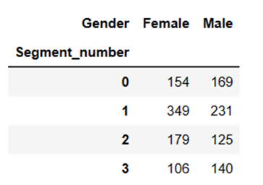

A visual inspection of this cross-tabulation suggests that there are no huge gender differences across segments. A solution is to draw the bars for women and men next to one another rather than stacking them (not shown). The disadvantage of this approach is that the absolute sizes of the market segments can no longer be directly seen on the y-axis. The mosaic plot offers a solution to this problem.

The mosaic plot also visualizes cross-tabulations. The width of the bars indicates the absolute segment size:

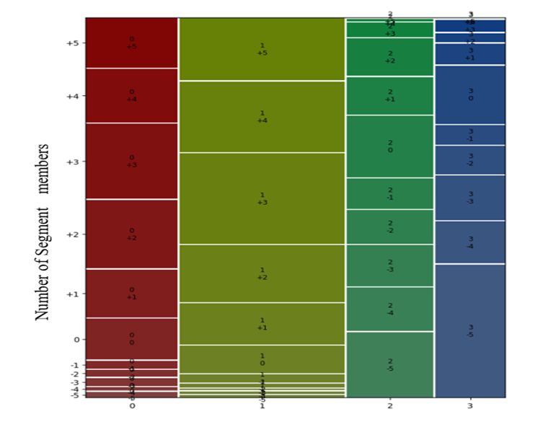

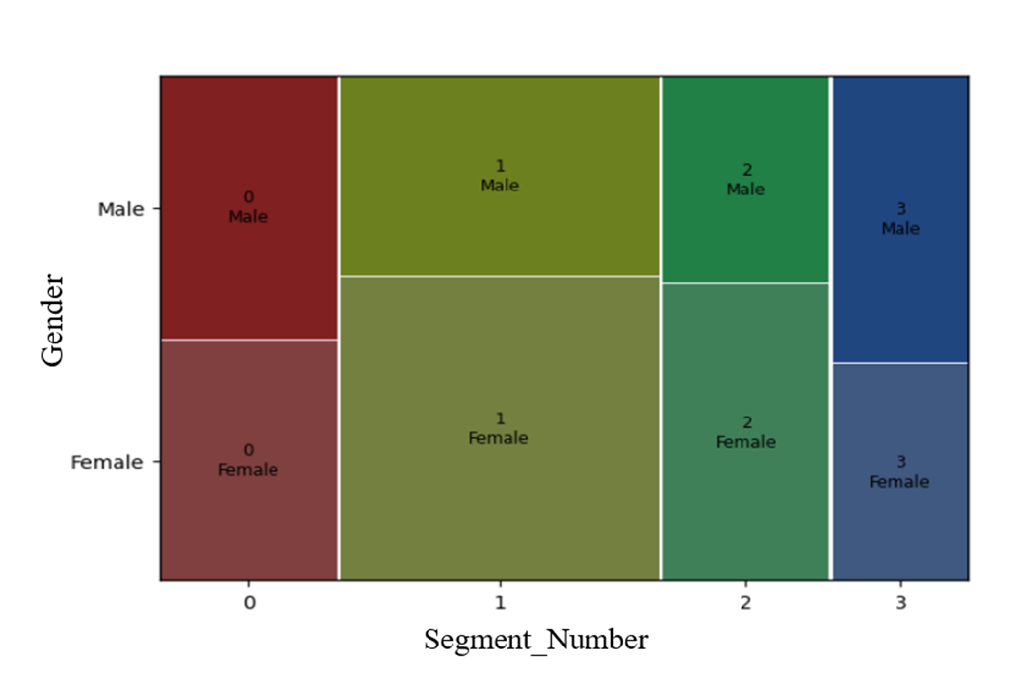

**Fig: Comparison of a stacked bar chart and a mosaic plot for the cross-tabulation of segment membership and gender for the mcdonalds data set**

We can gain additional insights by using a parallel box-and-whisker plot; it shows the distribution of the variable separately for each segment. We create this parallel box-and-whisker plot for age by market segment in python with the following command:

**sns.boxplot(x="Segment_number", y="Age", data=df)**

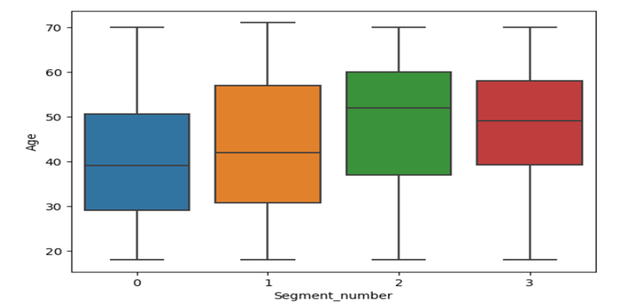

**Fig: Parallel box-and-whisker plot of age by segment for the mcdonalds data set**

1. **Testing for Segment Differences in Descriptor Variables**

* Using simple statistical tests to test for differences in descriptor variables across market segments.
* One way to do this is by running a series of independent tests for each variable of interest.
* Segment membership can be treated like any other nominal variable and represents a summary statistic of the segmentation variables.
* Therefore, any test for association between a nominal variable and another variable is suitable.
* The appropriate test for independence between columns and rows of a table is the chi-square test.
* To formally test for significant differences in the gender distribution across the Australian travel motives segments, the author suggests using an R command (which is not provided in the given text).
* The association between the nominal segment membership variable and another nominal or ordinal variable can be visualized using a mosaic plot.

1. **Predicting Segments from Descriptor Variables**

Predict segment membership from descriptor variables using regression analysis. This involves using a regression model with segment membership as the dependent variable and descriptor variables as independent variables. Regression models differ based on the function assumed for the dependent variable and the deviations between the dependent variable and the independent variables. The linear regression model assumes a linear function and normal distribution for the dependent variable. In R, the lm() function can be used to fit a linear regression model. The formula interface is used to specify the dependent and independent variables, and categorical variables are correctly interpreted. The passage provides an example of fitting a linear regression model for age in dependence of segment membership using the lm() function. The output shows the mean age for each segment. Overall, regression analysis can help identify critical descriptor variables for identifying segment membership and can test differences in all descriptor variables simultaneously.

**Step 8: Selecting the Target Segment(s)**

**The Targeting Decision:**

The selection of one or more target segments is a long term decision significantly affecting the future performance of an organization. This is when the flirting and dating is over; it’s time to buy a ring, pop the question, and commit. Optimally, therefore, all the market segments under consideration in this Step should already comply with the knock-out criteria. Nevertheless, it does not hurt to double check. The first task in Step 8, therefore, is to ensure that all the market segments that are still under consideration to be selected as target markets have well and truly passed the knock-out criteria test.

Once this is done, the attractiveness of the remaining segments and the relative organizational competitiveness for these segments needs to be evaluated. In other words, the segmentation team has to ask a number of questions which fall into two broad categories:

1. Which of the market segments would the organization most like to target? Which segment would the organization like to commit to?

2. Which of the organizations offering the same product would each of the segments most like to buy from? How likely is it that our organization would be chosen? How likely is it that each segment would commit to us?

**Market Segment Evaluation:**

The aim of all these decision matrices along with their visualizations is to make it easier for the organization to evaluate alternative market segments, and select one or a small number for targeting. It is up to the market segmentation team to decide which variation of the decision matrix offers the most useful framework to assist with decision making.

Whichever variation is chosen, the two criteria plotted along the axes cover two dimensions: segment attractiveness, and relative organizational competitiveness specific to each of the segments. E.g. Using the analogy of finding a partner for life: segment attractiveness is like the question Would you like to marry this person? given all the other people in the world you could marry. Relative organizational competitiveness is like the question: Would this person marry you? given all the other people in the world they could marry.

There is no single best measure of segment attractiveness or relative organizational competitiveness. It is therefore necessary for users to return to their specifications of what an ideal target segment looks like for them.

The value of each segment on the axis labeled How attractive are we to the segment? is calculated in the same way as the value for the attractiveness of each segment from the organizational perspective: first, criteria are agreed upon, next they are weighted, then each segment is rated, and finally the values are multiplied and summed up.

Typically profit potential is plotted. Profit combines information about the size of the segment with spending and, as such, represents a critical value when target segments are selected. In other contexts, entirely different criteria may matter. For example, if a non for profit organization uses market segmentation to recruit volunteers to help with land regeneration activities, they may choose to plot the number of hours volunteered as the bubble size.

**Step 9: Customizing the Marketing Mix**

* The marketing mix consists of various elements, including product planning, packaging, distribution channels, pricing, personal selling, branding, advertising, promotions, and servicing.
* Market segmentation should not be seen as an independent marketing strategy, but rather as a part of the segmentation-targeting-positioning (STP) approach.
* The STP approach involves market segmentation, targeting, and positioning, which should be integrated with other strategic decisions, such as competition and positioning.
* The marketing mix needs to be customized to the target segment, which may require changes to product design, pricing, distribution channels, and promotion strategies.
* The choice of segmentation variables depends on the specific purpose of the market segmentation analysis, such as informing pricing, advertising, or distribution decisions.

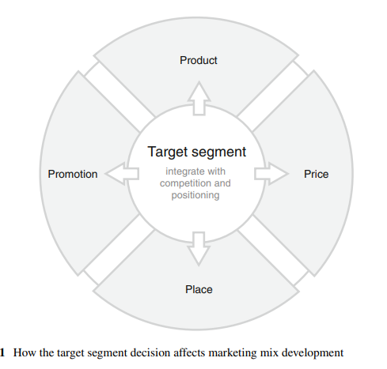

**TASK 2:**

**Replication of McDonalds Case Study in Python (GitHub link)**

Manda Shilpa

https://github.com/shilp0428/Feynn-Labs-Internship-Shilpa.git

**THANK YOU**